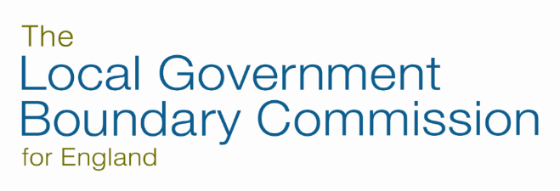

Acceptable behaviour

LGBCE’s website has been set up to help the public understand what we do and to encourage people to give views on our consultations.

When you contact us you must not:

- Give private information about other people
- Make defamatory or insulting comments about named individuals
- Include abusive, hateful or racist comments, content or links
- Include comments, content or links that encourage illegal activity or anything that infringes the intellectual property or privacy rights of others

When you contact us you will be engaging with a member of our team. Our team members will treat you with civility and have the right to expect the same in return. We reserve the right to take appropriate action if a member of our team is subject to abusive, hateful or racist comments.

